**P.RAJYALAKSHMI**

**192011200**

**28. Junit Testing to Check Whether the given Username is Valid or not**

**AIM**

To Perform junit Testing to Check Whether the given Username is Valid or not

**PROGRAM**

package sse;

import static org.junit.Assert.assertEquals;

import java.util.Scanner;

public class username {

public static void main(String [] args)

{

Scanner in=new Scanner(System.in);

System.out.println("enter the user name");

String str1=in.nextLine();

System.out.println("Reenter the user name");

String str2=in.nextLine();

assertEquals(str1,str2);

}

}

**OUTPUT**

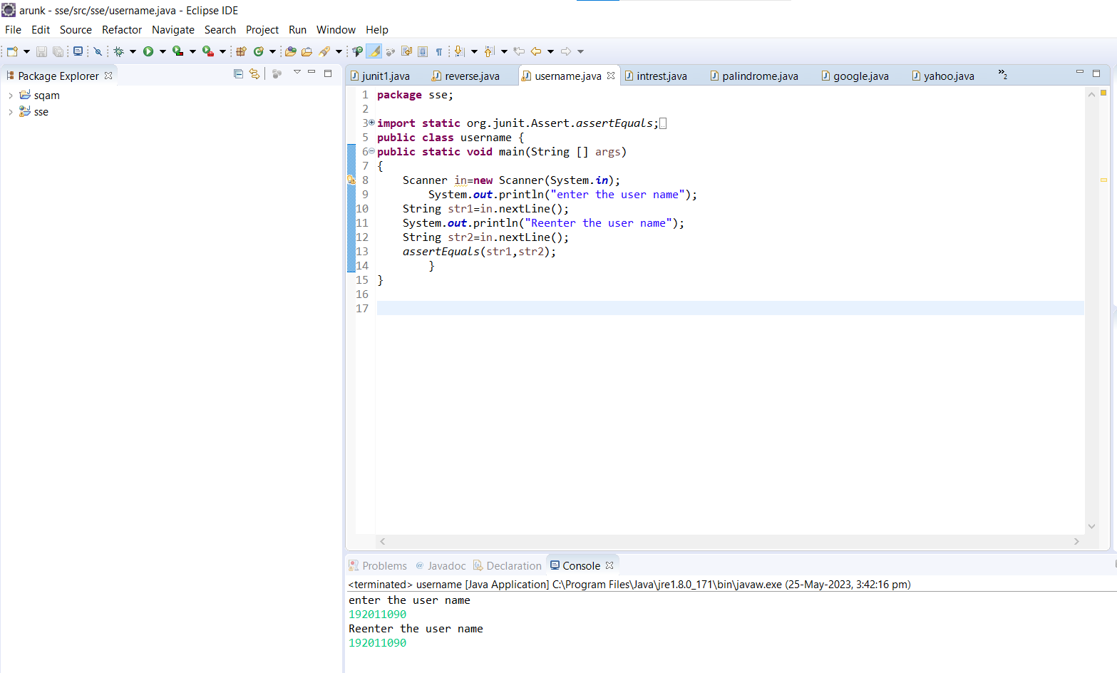

**RESULT**

Hence the junit Testing to Check Whether the given Username is Valid or not performed successfully.